MAYOR

Jimmy Watson

**CITY ATTORNEY**

Bobby King

CHIEF OF OPERATIONS

Jamie Etheridge

**CITY CLERK**

Tammy Payton

**MAYOR PRO TEM**

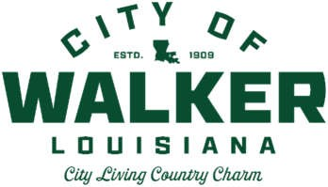Scarlett Milton Major

**COUNCIL**

David Clark Eric Cook Gary Griffin

Scarlett Milton Major Richard Wales



CITY COUNCIL MEETING AGENDA

**January 10, 2022 6:00 PM**

# CALL MEETING TO ORDER/ROLL CALL MAYOR

1. MINUTES / COMMENTS – December 13, 2021 Council Meeting MAYOR

# FINANCE REPORT COTTON

1. ADDITIONAL COMMENTS MAYOR

# ADJOURN MAYOR



**Pursuant to Louisiana Revised Statute 42:17, the Mayor and City Council of the City of Walker may adjourn into executive session to discuss pending litigation, security or personnel issues or any other matters provided for by the legislature.

**Pursuant to Louisiana Revised Statute 42:14, the public will be allowed to make comments before each item on the agenda requiring a vote of the City Council.