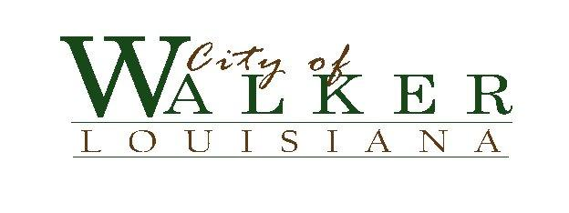
ALCOHOL BEVERAGE CONTROL BOARD MEETING
AGENDA

MONDAY, April 7, 2014 @ 9:00 A.M.

1. Meeting called to order …………………………………………………. Raiford
2. Roll Call …………………………………………..………………………. Frey
3. Approval of January 22, 2014 Minutes…………..……………………….. Raiford
4. Revisions to Alcohol Ordinance ………………..………………………… Raiford
5. Adjourn………………………………………………………………………Raiford

BOARD MEMBERS:
Fred Raiford, Chairman
William Aydell * Ryan Dutsch * Belinda McCullough * Denver Populis * Myra Streeter * Brenda Tedder

POSTED: April 2, 2014 @ 9:30 a.m.

ALCOHOL BEVERAGE CONTROL
BOARD MEETING

monday, april 7, 2014 @ 9:00 A.M.

BOARD MEMBERS:
Fred Raiford, Chairman
William Aydell * Ryan Dutsch * Belinda McCullough * Denver Populis * Myra Streeter * Brenda Tedder

